

Christmas Day Lunch 2023
Champagne cocktail and festive canapés
~

Spiced parsnip and apple velouté with thyme foam GF DF V
~

Pan seared scallops, cauliflower purée, crispy pancetta, wilted spinach, micro leaf salad GF DF

Roast pigeon breast, butternut squash and garlic risotto, watercress leaves, beetroot crisp GF

Medley of game bird crispy bon bon; partridge, pheasant, quail,
celeriac and red onion remoulade, wholegrain mustard dressing

Broccoli and smoked dapple cheese tartlet, tomato and red onion concasse, coriander dressing oil, red vein sorrel V
~
Lobster, crayfish, crevettes and smoked Scottish salmon,
prosecco jelly, pickled cucumber, marie rose dressing, pea shoots GF DF
~
Butter roasted Norfolk turkey breast, bread sauce, duck fat roast potatoes,
roast parsnips, chantenay carrots, brussel sprouts, roast gravy

Papworth Butchers 28 Day aged Fillet of Beef, fondant potato, confit carrots, baby courgettes,
roasted salsify, parsnip purée, madeira jus GF DF

Herb crusted cod fillet, buttered parsley mash, braised red cabbage, tender stem broccoli, white wine velouté

Butternut squash, mushroom and beetroot wellington, roasted winter medley of vegetables,
new potatoes, white wine reduction V
~
Christmas pudding, brandy sauce, redcurrants V

Vanilla crème brulée, winter berry compote, sable biscuit V

Sticky toffee pudding, toffee sauce, vanilla ice cream V

Trio of chocolate, white chocolate cheesecake, dark chocolate brownie, milk chocolate sorbet V

Apple and pear frozen parfait, cinnamon brandy snap, meringue pieces, caramel sauce V
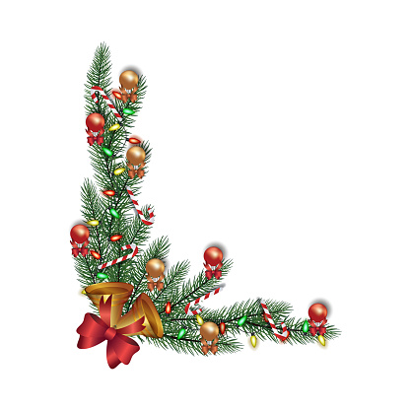
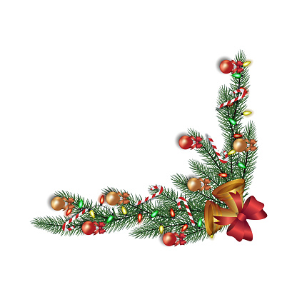
Selection of artisan cheeses; Binham blue, Norfolk Smoked Dapple,
Baron Bigod Suffolk Brie, Barbers mature cheddar with celery and grapes V

European and Tropical fruits V&GF

Selection of homemade ice creams and sorbets V&GF
~
La cafetière coffee and petits fours and mince pies
£110.00

