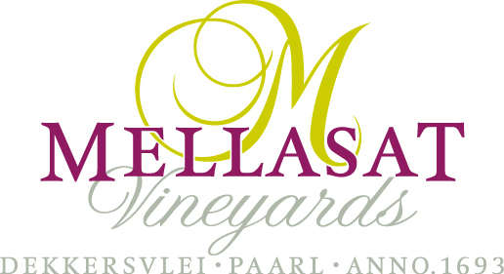

Retail Price List for Mellasat Wines

Wine | Case of 6 | Bottle
Dekker’s Valley Seraphic  An unwooded blend of Chardonnay, Viognier and Chenin Blanc that was blended to provide an integrated expression of fruit purity. Floral hints of peach and apricot blossom on the nose from the aromatic characteristics of Viognier give way to apple crispness on the initial palate, following through to the full ripeness of Canteloupe melon. | £57.00 | £9.50
Dekker’s Valley Shiraz Rosé  A distinctive salmon colour this rosé oozes summer fruit and red berries and has a dry finish. An easy every day drinking wine styled for summer lunches and aperatifs. | £57.00 | £9.50
Dekker’s Valley Revelation  A smooth and fruity red made from Cabernet Sauvignon, Shiraz, Pinotage, and Tempranillo. Lightly wooded with accessible fruit makes this a wine that can be enjoyed today. A great wine to have available for last minute entertaining! Food pairing suggestions include roast meats and grills | £57.00 | £9.50
Mellasat Shiraz  ‘Pepper, spice and everything nice’ with hints of mulberries and white pepper, this is a warm climate Shiraz at its best. The wine was barrel matured for 39 months. Food pairing suggestions include lamb chops, pork belly and roast chicken. | £69.00 | £11.50
Mellasat Chardonnay  Barrel fermented and matured for 11 months in the Burgandian style. Hints of citrus and quince balance elegantly with good acidity to give an elegant mouth feel. Partial Malolactic fermentation together with lees stirring in the barrel assist with the structure of this wine which is a more medium bodied wine. Food suggestions include oysters, lobster, smoked salmon and light salad. | £75.00 | £12.50
Mellasat ‘∑’ White Pinotage  Making white wine from red grapes using South Africa’s unique Pinotage grape! Whole bunch pressed immediately after picking prevented the juice from obtaining colour from the skins. Barrel fermented and matured for 11 months with lees stirring for that slightly creamy and nutty character, but also exuding tropical fruit flavours. Food pairing suggestions include strong flavoured fish and seafood, mild curries such as chicken korma, tikka and some Asian dishes | £75.00 | £12.50
Mellasat Viognier  These Viognier grapes were picked at optimum ripeness, and the resultant wine is barrel fermented and matured for 11 months. This wine has prominent floral notes of orange blossom on the nose that leads through to peach and apricot flavours on the palate. The wine can also be enjoyed by itself now or cellared for mature drinking. Food pairing suggestions include chilled summer soups, grilled salmon and pan fried seafood. | £90.00 | £15.00
Mellasat Tempranillo  This wine was matured in a combination of American (33% new) and French oak barrels for 36 months, with the nose giving a cigar box aroma leading to marinated cherry and autumn blackberry on the palate. Given the balance of tannins and structure, it is expected this wine will continue to develop for several years to come. Food pairing suggestions include chorizo and other cured meats, slow cooked lamb shank on a bed of polenta and hearty casseroles. | £135.00 | £22.50
Mellasat M 2014 Cabernet Sauvignon  2014 Vintage. Cassis and dark fruits on the nose that follow to the palate. This wine reflects the aged mobility of Cabernet Sauvignon. Matured in French oak barriques and in bottle for up to five years before release, culminating in a wine that is structured, well balanced and time honoured. | £150.00 | £25.00
Mellasat White Pinotage Brut MCC  Pale straw, fine mousse, on the nose there are hints of lemon meringue, lemon zest, fresh pears and brioche. Very fresh entry, not bone dry with lemon, pear drop, creamy panna cotta and a fruity sweetness on the after taste. Very refreshing, only 10.5% alc. Made from the first batch of White Pinotage, a non-vintage of the 2017 and 2018 vintages, only one barrel from each vintage. Older wood. | £150.00 | £25.00

